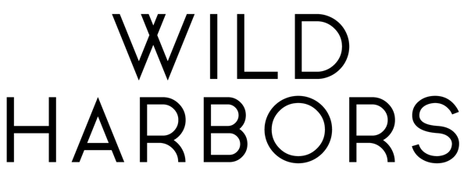

Forty years. That’s how long the Israelites wandered in the desert before they entered the Promised Land. It’s true, they were a forgetful people; but along the way, they built monuments—reminders of God’s faithfulness throughout their journey. We, too, are forgetful. That’s why it's important to be reminded of the places where God moved in our past, so we can be expectant of the ways He’ll move in our future. For husband/wife alt-pop duo Wild Harbors, building a monument became not just a significant ritual but an affirmation that the good things in life are worth the risk.

The couple’s full-length debut, Monument, is a tribute to the altars they’ve built and the chances they’ve taken to create a life together in music and marriage.
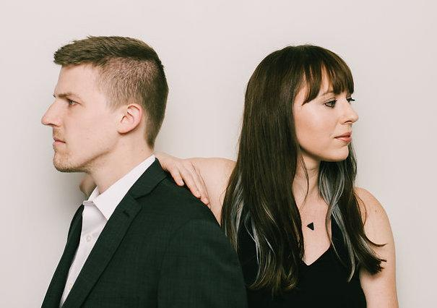
Chris Badeker met Jenna on his first day at McDaniel College in Westminster, Maryland. They started singing together long before they were a couple, playing ’90s cover songs and leading worship at on-campus events. Following graduation, they began dating and eventually married, honing their penchant for songwriting along the way. Since then, Wild Harbors has released two EPs—Monument Part One and Monument Part Two—and their songs “Abigail” and “House On Fire” were named among UTR Media’s top tracks of 2018. They’ve also had numerous selections featured on such Spotify playlists as Indie Spirit, Faith Finds and New Music Friday.

“God kept opening doors for us,” Jenna shares of their initial musical opportunities. “I don’t know that we had any visions of being a band, but we just kept showing up and feeling called to write, and people kept inviting us to play.”

When they were offered the chance to spend a month in Nashville recording with acclaimed artist and producer Andrew Osenga (Laura Story, Caedmon’s Call), the Badekers weighed their options prayerfully and accepted the opportunity. The experience ultimately helped galvanize their mission as a duo, and soon they were transitioning from full-time jobs to the full-time pursuit of music. It was a calling that felt divinely appointed, albeit a bit scary.

“We’ve been established for quite a while in a different kind of life trajectory,” Jenna shares of leaving her job as an elementary school teacher. “It’s honestly been terrifying to me, trying something new and stepping out into this. But we’ve been so moved by the people we’ve talked to throughout this process who have shared their own secret dreams and desires God called them to that they really enjoy.”

“Sometimes when it’s hard, it’s not wrong,” adds Chris of their decision to make a solid commitment to music. “It just means you need to move toward it and press into it more.”

During the creative process for Monument, the couple began to peel back layers of unacknowledged anxiety. Songwriting became unintentional catharsis. “The songs brought out ideas I wasn't ready to admit yet—they illuminated fears I had and revealed decisions that needed to be made," Jenna reflects. "I didn't know if I was ready to have those conversations, but they came out in the music we were writing.”

At the intersection of artistic pop and organic singer/songwriter, Monument serves as a fitting introduction to the Maryland-based couple behind Wild Harbors. Chris and Jenna exude an immediate warmth and authenticity across interlaced harmonies, quirky melodies and rich storytelling.

"I don't want the music we play to be so tied to a certain label, Christian or otherwise, that someone outside that sphere would think, 'That's not for me,' before they hear it," Chris explains. “Sometimes it’s scary to be treading that line a little bit, but it feels authentic to us, so we keep doing it.”

“We’re trying to be obedient to write from authentic experience,” Jenna adds. “People value honesty and conviction, and they value those who can be completely bold and sold out. I hope our friends who aren’t believers are hearing messages in our music they can connect with. They also see that we’re not being apologetic about what we believe or who we are.”
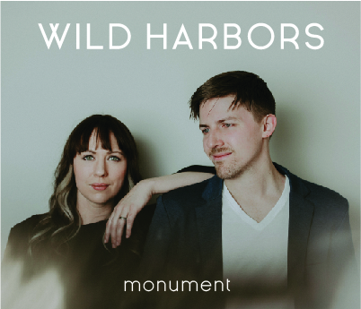
Two particularly poignant selections on the album reflect the couple’s fears for their marriage. Brooding ballad “Alone Together” unpacks Jenna’s worry that the relationship would ultimately bring isolation down the line. “I was afraid of getting married and living a really lonely life inside that marriage,” she shares. “I think we see that in a lot of relationships, especially in the social media age, where we have tons of interaction with people but there’s no intimacy. Everyone’s more connected than ever, but they’re lonelier than ever because that connection comes through a computer screen.”

Conversely, Chris feared the tension that marriage would inevitably hold. The passionate “House On Fire” is his battle-cry after witnessing his parents' divorce as a child, resulting in his own tendency to avoid conflict. “One of the things I realized very, very quickly was I had no clue how to deal with conflict in our marriage. Sometimes you need to move toward things that are scary. It’s the only way to love people, and that’s the only way to grow.”

Other tracks reveal the depth of the duo’s storytelling abilities. The prayerful “Abigail” tells of a family friend who gave birth to twin daughters—one of whom she was told would not survive. After two life-threatening instances, today Abigail is a thriving teenager Chris and Jenna claim as a surrogate niece. “Her story made us want to treasure the people around us and treasure the lives we’re entrusted to know in our time here,” Jenna says.

Meanwhile, the imaginative “Ballad of Wallace and Jessie” takes its inspiration from a story Chris read about a young orphan in Scotland named Jessie, who had a premonition of the Titanic sinking shortly before she passed away. In her dream, Jessie saw a man named Wallace playing the violin on the ship’s deck, calming passengers on their way to the lifeboats. The couple was struck by Wallace’s “creative sacrifice” and decided to wrap a melody around his story. “His music literally saved people’s lives in a very real way,” offers Chris. “He realized he could use his talent in that moment, at great cost to himself, to get people through this tragedy.”

“The heart of that story is that someone would lay down their life for another,” Jenna adds. “For us, that’s the heart of Christ.”

Truth. Beauty. Narrative. That’s what Wild Harbors sets out to capture through their music. Monument simply marks the beginning of their musical journey—one they hope inspires others to realize their dreams too.

“We want listeners to be able to approach their own stories, their own decisions, and the things before them with some hope and determination,” Jenna says. “In the process of making this record we have stepped out to do the thing that really makes us feel alive, and that’s what we hope other people would be able to do as well. We all benefit so much from taking those risks in life.”

